Checkpoint 1
Course: AIN4312 — Special Topics in Artificial Intelligence II
Project Title: AI-Based Smart Energy Management and Web-Controlled Simulation System

ABSTRACT
The project develops an intelligent web-based system which uses artificial intelligence to analyze and optimize smart building energy consumption through simulation. The platform functions as a digital twin which duplicates sensors and devices and energy data to enable users to monitor and control operations through an online interface. The system will employ Deep Q-Network (DQN) reinforcement learning model will discover efficient control methods which achieve maximum comfort while minimizing energy consumption. The system includes a dynamic calibration system which determines energy behavior for all virtual devices and a controlled system for smooth daily operation. The system includes an automatic alert system which detects when energy usage exceeds normal levels. The system aims to develop an interactive simulation platform which will evolve into operational systems for real-world applications.

1. OVERVIEW

1.1 Need Identification
The current energy management systems use fixed or user-controlled systems which fail to adapt to changing conditions thus resulting in energy waste. The project develops an expandable web-based testing platform which enables researchers to test AI-based energy management systems through virtual simulations without needing physical equipment. The system functions as a testing environment for advanced decision systems which optimize energy usage automatically.

1.2 Problem Definition
Smart home systems today perform automated tasks but they fail to predict upcoming usage patterns and adapt their operations accordingly. The systems operate based on pre-programmed schedules and user-inputted information. The system uses reinforcement learning to train an agent which discovers the best energy-saving strategies while preserving comfort levels. The RL agent learns to adapt its behavior through simulated conditions because each virtual device operates with distinct power consumption patterns.

1.2.1 Functional Requirements
The system requires a web-based interface to show device and room information alongside total energy usage in real-time.
The system produces artificial environmental information which includes temperature and humidity levels and energy requirements with accurate simulation parameters.
The system requires a DQN agent with the ability to perform hourly control operations.
The system requires a central calibration file which contains default consumption values and comfort thresholds for all devices.
The system requires a controlled mechanism to perform gradual changes in environmental conditions.
The system includes an alert system which activates warnings when energy usage or temperature values exceed their predetermined safety thresholds.

1.2.2 Performance Requirements
The RL training process needs to run for 50 episodes which represent 50 days of simulation to achieve stable convergence.
The system needs to achieve a predictive accuracy of R² ≥ 0.85.
The system needs to respond to decisions within one second or less.
The system needs to reduce total energy usage by at least 20% when compared to random control operations.
The system needs to maintain operational status at 99% or higher during simulation time.

1.3 Proposed Solutions
The system consists of multiple interconnected components which work together as a single unit. The SmartHomeEnv class creates a virtual environment which models energy distribution and thermal behavior. The system performs energy usage calculations and temperature differences and comfort level assessments during each simulation iteration. The ImpactCalibrator module automatically determines how control actions affect energy consumption and temperature levels. The RLAgent uses PyTorch to build a DQN model which learns efficient energy-saving strategies by performing trial-and-error experiments.
The system operates through a continuous feedback system which combines sensing with decision-making and execution functions. The web interface shows users real-time system logs and energy performance indicators and system analytics. The system operates in a simulated environment at present but its API-compatible design enables future integration with actual IoT devices.

1.4 Literature Review
Research studies from recent years demonstrate that reinforcement learning techniques produce optimal results for energy management systems. The IEEE (2023) study showed that DQN-based systems achieved a 25% decrease in HVAC energy consumption. The research published by Elsevier (2024) demonstrated that reinforcement-based energy controllers maintained stable indoor temperatures during changing environmental conditions. The optimization of data center operations at Google DeepMind and smart energy research at MIT have proven that artificial intelligence systems can make autonomous decisions about energy usage. The research findings support the development of DQN learning systems for virtual simulation-based intelligent risk-free energy management.

1.5 System Architecture
The system consists of six interconnected layers which operate together as a single system.
- The Virtual Sensors Layer produces artificial environmental information which includes temperature readings and humidity levels and energy consumption data.
- The Device Management Layer establishes definitions for devices and energy parameters and sets operational access rules.
- The SmartHomeEnv environment simulation layer operates as a system that models how energy and temperature levels change.
- The RLAgent AI layer uses DQN-based learning to find the best possible energy management solutions.
- The ImpactCalibrator module operates as a calibration system which automatically creates rules that link energy consumption to temperature levels.
- The Web Dashboard serves as the User Interface Layer which shows users real-time performance data and warning notifications and analytical reports.

2. WORK PLAN

2.1 Work Breakdown Structure (WBS)
The project timeline includes six phases which span from Weeks 1–3 to Weeks 12–13.
Phase | Duration | Tasks
Phase 1 | Weeks 1–3 | Build simulation environment and device catalog and calibration module
Phase 2 | Weeks 4–6 | DQN implementation and virtual environment integration for RL
Phase 3 | Weeks 7–9 | The RL model receives training while reward function optimization and learning curve analysis take place.
Phase 4 | Weeks 10–11 | The development team creates a complete web interface which connects to active data streams.
Phase 5 | Weeks 12–13 | The system receives an alert system and KPI monitoring dashboard implementation.
Phase 6 | Week 14 | The project team conducts final testing before fixing errors and submitting their report.

2.2 Team Responsibilities
The Project Manager maintains complete control over all system phases to achieve full system integration.
The AI Engineer designs and trains the DQN model while working to maximize its performance.
The Web Developer creates the dashboard interface through front-end development while connecting it to FastAPI back-end services.
The Data Engineer creates the calibration system and develops methods to produce artificial data.
The Tester/QA team conducts system verification tests while performing stability assessments and validation checks.

APPENDIX A

Simulation and Data References
The following list shows all sources used for the project.
Source | Description
Device Catalog | JSON file listing devices, base power (kWh), and available permissions
Impact Map | Auto-generated file mapping keywords to energy/temperature coefficients
Home Configuration | JSON file defining virtual rooms, devices, and comfort ranges
Training Logs | Contains RL states, actions, rewards, and performance KPIs

System Workflow
The system operates through a continuous process of virtual sensor data production.
The SmartHomeEnv system processes data to establish the current system state.
The RLAgent system uses state analysis to determine the best possible action for execution.
The environment system makes changes to energy and temperature changes based on the system state.
The dashboard shows users real-time performance data and decision information and alert notifications.

Model Evaluation Results
The system underwent testing to verify how well the learning models predict actual results.
The following figure (Figure 4) shows the comparison between actual and predicted results for two parameters.
The predicted values match real-world dynamics at a low level of deviation for both temperature and energy consumption.
The system uses actual energy usage patterns to generate predicted energy consumption values.
Figure 4 — Model Prediction Accuracy (Actual vs Predicted)
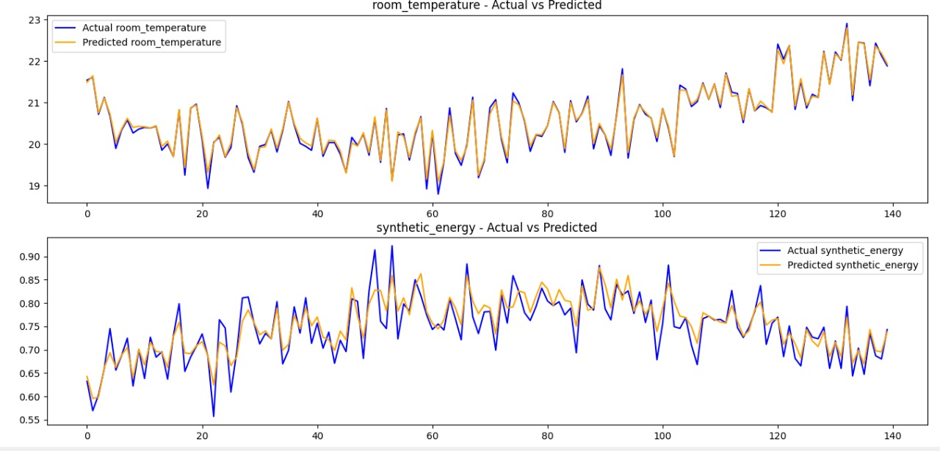

The system shows actual and predicted values for room temperature and synthetic energy consumption across 150 simulated steps.
The model achieved successful parallelism between predicted and actual values which proved the learning and calibration modules operated correctly.

Expected Results
The RL model reaches stability at episode 40.
The system achieves a 15-20% decrease in its simulated energy usage.
The system provides users with real-time visualization of energy distribution and control system operations.
The system generates instant alerts whenever comfort levels or energy usage exceeds established limits.

Future Development
The system will link to actual IoT devices through REST or MQTT APIs for data exchange.
The system will expand its capabilities to manage energy distribution between different buildings.
The system will incorporate solar panels and battery storage systems as new renewable energy sources.
The system will receive new features which include predictive maintenance capabilities and adaptive scheduling functionality.

